Housing (Wales) Act 2014
Agent Training Course

This resource is to enable you to create notes while you are working through the Agent Training Course modules.
Each page highlights a module topic and the main points covered.
Write on the document by clicking on the grey text box found on each page and start typing.
Save or print.
You may find this a useful aid during the online assessment and also for your future reference.

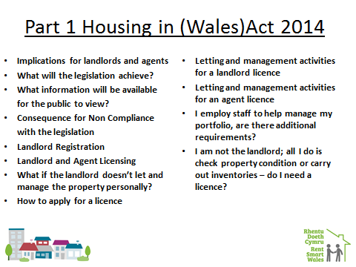

Type Here:

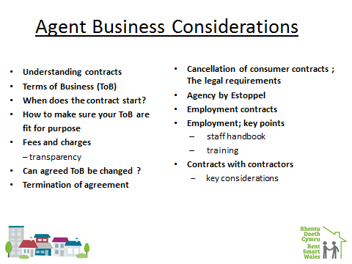
Type Here:

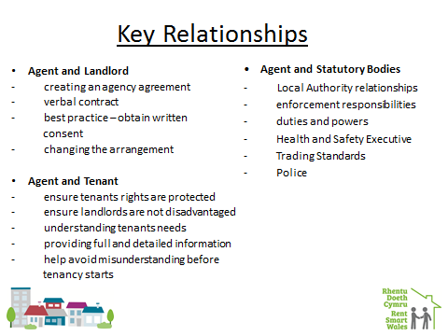
Type Here:

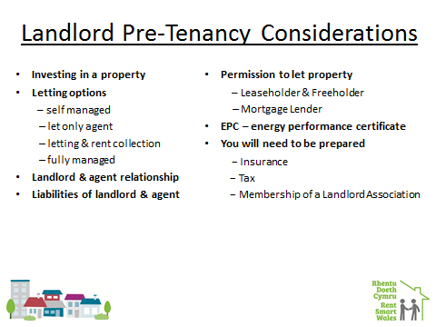
Type Here:

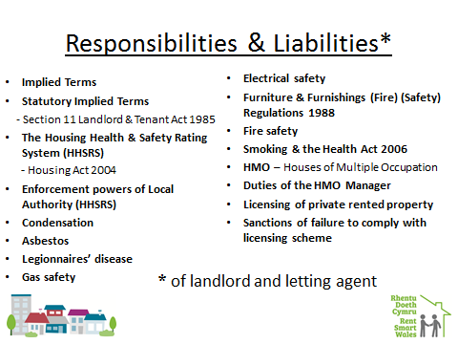
Type Here:

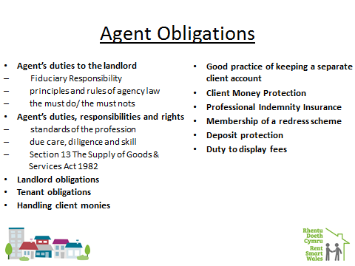

Type Here:

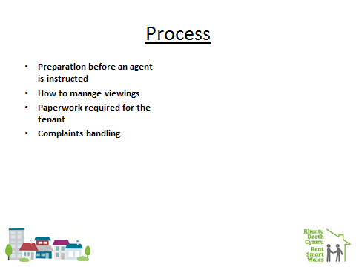
Type Here:

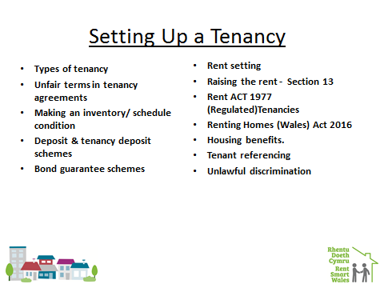
Type Here:

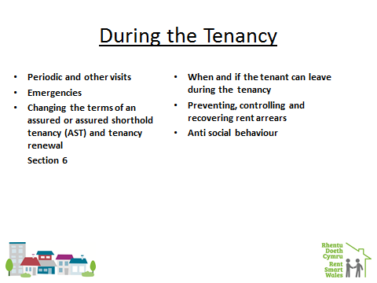
Type Here:

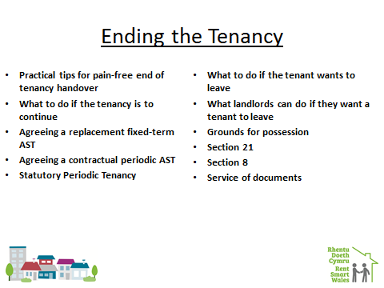
Type Here:

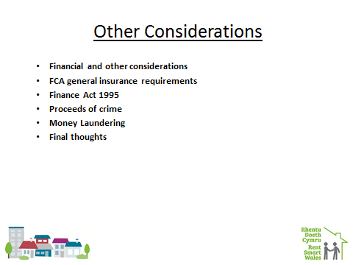
Type Here:

